4537 Embedded programming essentials

Home Work assignment 1: Toggle a GPIO Pin

Total number of hours: 36

* Set up:
* LPC1768
* Breadboard
* Register to mbed
* GPIO pin 7:port 0 pin
* Downloaded Virtual box, gcc, IAR.
* Created account on github
* C code to toggle GPIO pin (7):

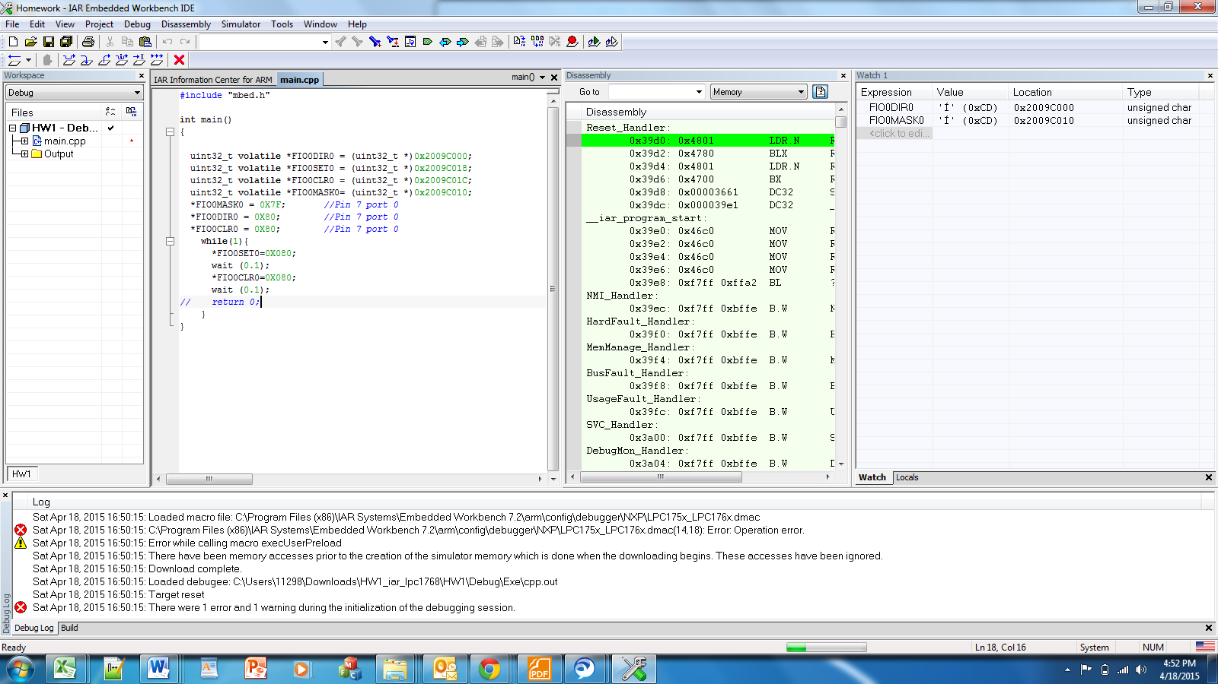

**Assembly instructions:**

Cortex M3 uses 3 stage pipelines for instruction execution:

* Fetch🡪Decode🡪execute
* Next instruction is fetched while decoding and execution of previous instruction is on-going.
* The code above takes 5 instruction cycles to run as shown below:

